**Quick Info**

**Born:** 384 BC

Stagirus, Macedonia, Greece

**Died:** 322 BC

Chalcis, Euboea, Greec

**ARISTOTLE BIOGRAPHY**

Aristotle was a Greek philosopher. born in Stagirus, or Stagira, or Stageirus, on the Chalcidic peninsula of northern Greece. His father was Nicomachus, a medical doctor, while his mother was named Phaestis. When Aristotle was about ten years old his father died. In 367 BC Aristotle, at the age of seventeen, became a student at Plato's Academy. Aristotle travelled from Athens to Assos which faces the island of Lesbos.

Aristotle married Pythias, daughter of Hermias, they had one child, a daughter also called Pythias. However, Aristotle's wife died about 10 years after their marriage. Aristotle did not marry again after the death of his wife, but he did form a relationship with Herpyllis, who came from his hometown of Stagirus. It is not clear when they first met but together, they had a son, Nicomachus, named after Aristotle's father.

Aristotle became the leader of the group of philosophers which Hermias had gathered. However, Aristotle's time in Assos was ended by some political events. The Persians attacked the town which Hermias was captured and executed. from Assos, the group they created, continued their biological research there.

In 343 BC Aristotle reached the Court of Macedonia and he there to remain for seven years. The often-quoted story that he became tutor to the young Alexander the Great, the son of Philip.

In 335 BC Aristotle founded his own school the Lyceum in Athens. The Academy had always been narrowed in its interests, but the Lyceum under Aristotle pursued a broader range of subjects.

After the death of Alexander the Great in 323 BC, anti-Macedonian feeling in Athens made Aristotle retire to Chalcis where he lived in the house which had once belonged to his mother and was still retained by the family. He died the following year from a stomach complaint at the age of 62.

Approximately 200 works of Aristotle, only 31 survive.

**Quick Info**

**Born:** 428 BCE or 427 BCE

Athens ancient Greece

**Died:** 348 BCE or 347 BCE

Athens ancient Greece

**PLATO BIOGRAPHY**

Plato is an ancient Greek philosopher, student of Socrates (c. 470–399 BCE), teacher of Aristotle (384–322 BCE), and the founder of the Classical Athens. Born in Athens. His father is Ariston, who dies when Plato was a child. his father’s side claimed descent from the god Poseidon. His mother is Perictione, who remarried the politician Pyrilampes. his mother’s side was also related to the lawgiver Solon. Both sides are from famous wealthy families who had lived in Athens for generations.

Plato as a young man was a member of the circle around Socrates. The works of Plato commonly referred to as “Socratic” represent the sort of thing the historical Socrates was doing.

The Peloponnesian War was fought between Athens and Sparta between 431 BC and 404 BC. Plato was in military service from 409 BC to 404 BC. Which he thinks that he wanted a political career rather than a military one. He joined the Thirty Tyrants, but he quickly left.

in 399 BC, Socrates was executed. Which had a profound effect on him and made Plato left Athens and travelled in Egypt which he learnt the water clock and later introduced it into Greece. In Italy where he learned the work of Pythagoras and came to appreciate the value of mathematics, and Sicily.

In 387 BC, Plato returned to Athens, and founded his Classical Athens Academy. The Academy was devoted to research and instruction in philosophy and the sciences, and Plato presided over it from 387 BC until his death in 347 BC. For 20 years Aristotle was also a member of the Academy. He started his own school, the Lyceum, only after Plato’s death, when he was passed over as Plato’s successor at the Academy.

in 367 BC, He went to Syracuse following the death of Dionysius I who had ruled the city. Dion, the brother-in-law of Dionysius I, persuaded Plato to come to Syracuse to tutor Dionysius II, the new ruler. Plato did not expect the plan to succeed but because both Dion and Archytas of Tarentum believed in the plan then Plato agreed. Their plan was that if Dionysius II was trained in science and philosophy. However, Dionysius II was jealous of Dion whom he forced out of Syracuse and the plan, as Plato had expected, fell apart.

In 361 BC, Plato returned to Athen to visit Syracuse hoping to bring the rival together. However, He did not achieve a political solution and dion attack Syracuse in 357 BC, gained control but was murdered in 354 BC.

His most works contain discussions in aesthetics, political philosophy, theology, cosmology, epistemology, and the philosophy of language.

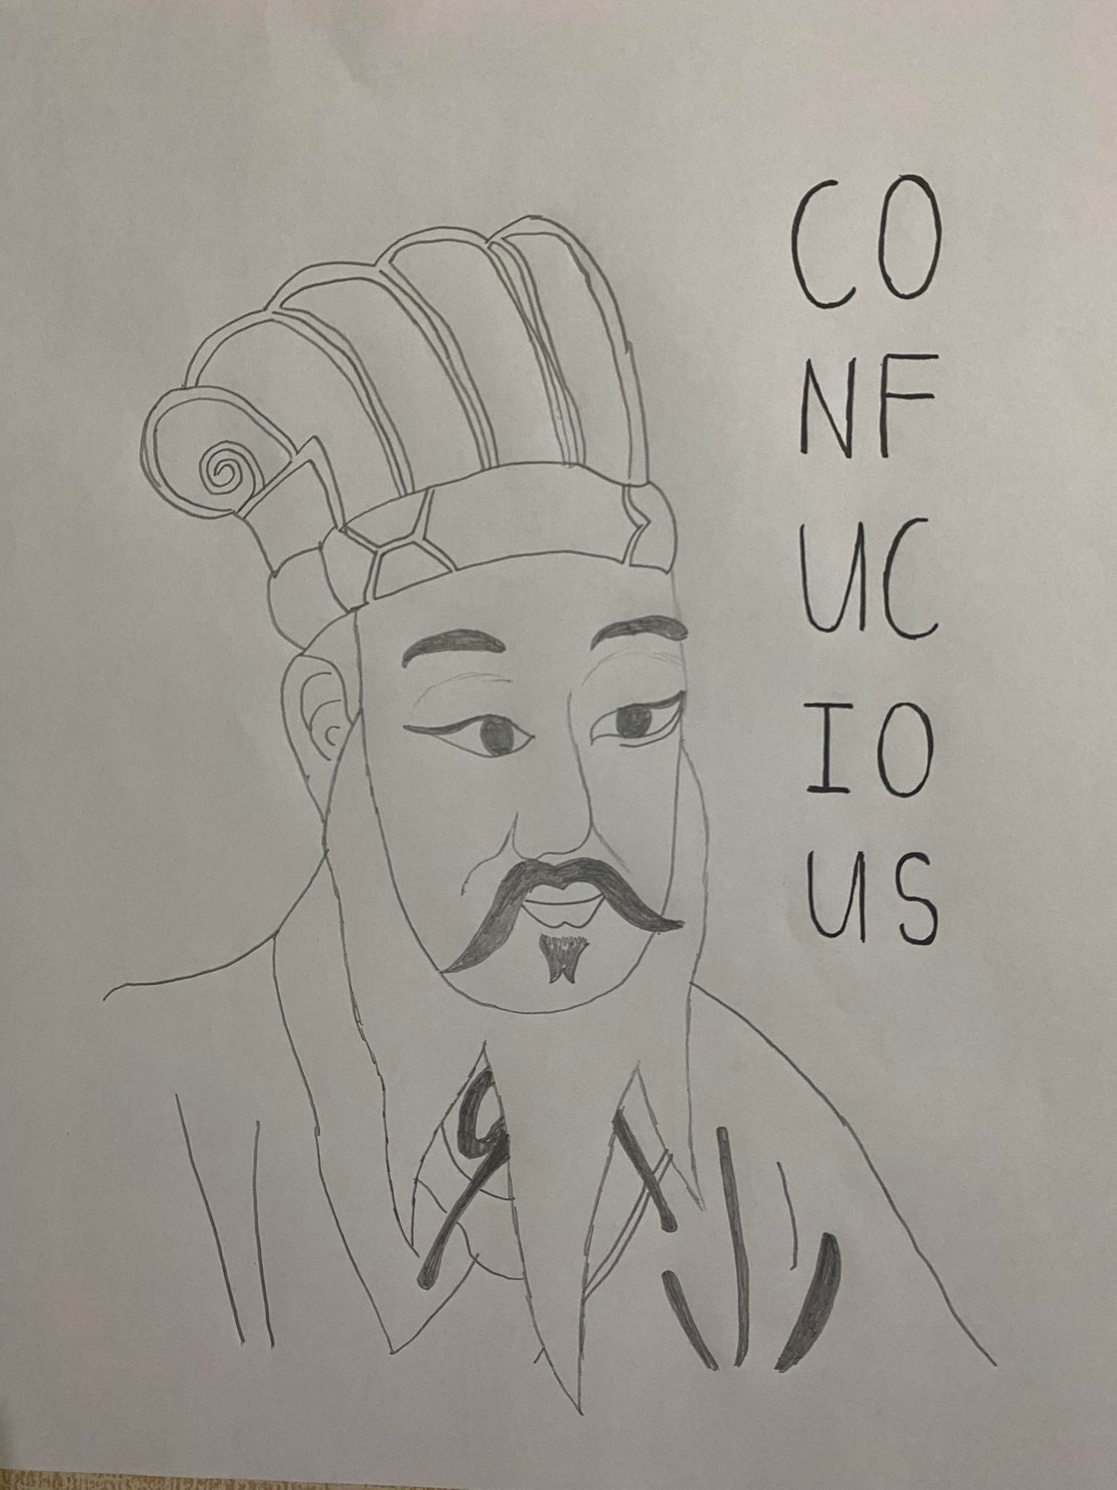

**Quick Info**

**Born:** 551, Qufu, state of Lu [now in Shandong province, China]

**Died:** 479 bce, Lu

**CONFUCIUS BIOGRAPHY**

Confucius is a China’s most famous teacher, philosopher, and political theorist. His home was in Lu, a regional state of eastern China in what is now central and southwestern Shandong province. Confucius’s early ancestors were the Kongs from the state of Song—an aristocratic family that produced several eminent counselors for the Song rulers. Confucius’s father, Shu-liang He, had been a warrior and served as a district steward in Lu. But soon after, it died after Confucius’s birth.

He found employment first with the Jisun clan as minister of crime. A few years later, A major clash took place in 498 BCE. A plan to steer the families toward self-ruin backfired. The heads of the families suspected Confucius, and so he had no choice but to leave his position and his home.

While Confucius is on a long journey: first to Wei, the state just west of Lu, then southward to the state of Song, and finally to the states of Chen and Cai. The journey lasted 14 years, and Confucius spent much of that time looking for rulers who might be willing to accept his influence and be guided by his vision of virtuous government.

The man Confucius looked back to for inspiration and guidance was Zhougong. Despite the temporal distance between them, Confucius believed that he and the Duke of Zhou wanted the same thing for the dynasty: social harmony and political stability grounded in trust and mutual moral obligations, with minimal resort to legal rules.

Confucius’s disciples were considerably younger than him. He did not actively recruit them when he was a counselor in Lu. He did not find any school or academy. Young men from a wide range of backgrounds—sons of aristocrats, children of common gentlemen, merchants, farmers, artisans, and even criminals and sons of criminals—chose to attach themselves to him in order to learn from him skills that might get them started on a path toward an official career.

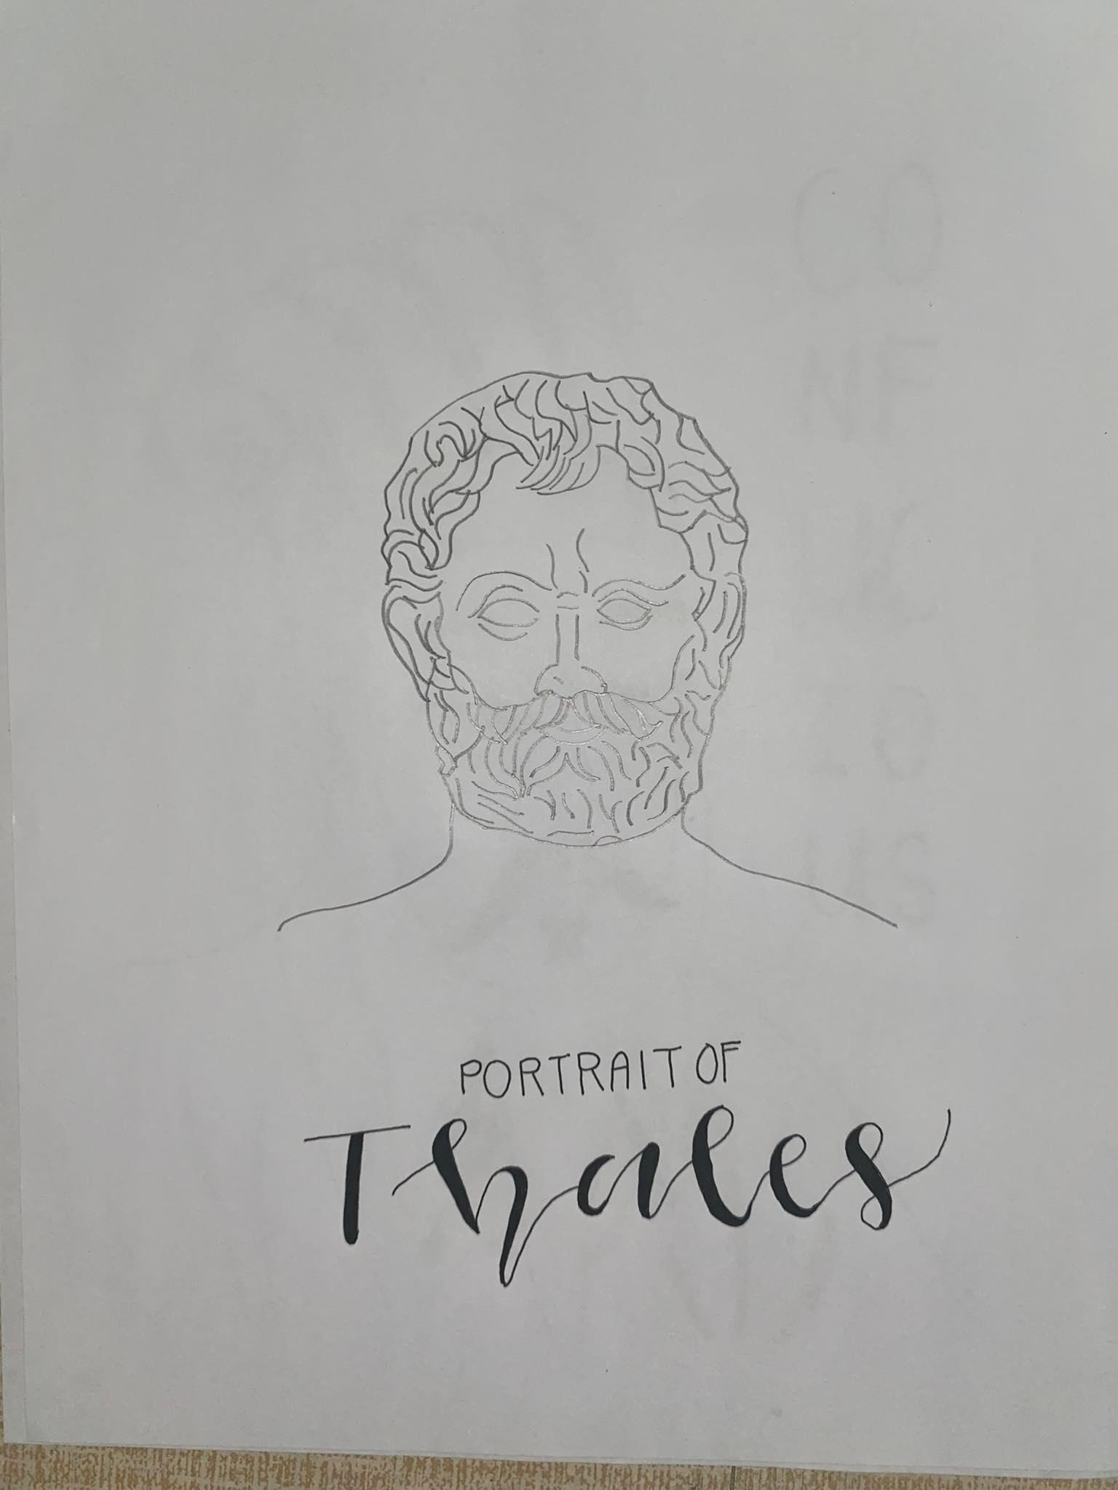

**Quick Info**

**Born: c. 624–620 bce**

Miletus, village of Balat in Aydın Province, Turkey.

**Died: c. 548–545 bce**

Miletus, Asia Minor (now Turkey)

**THALES BIOGRAPHY**

Thales is the first known Greek philosopher, scientist and mathematician although his occupation was that of an engineer. He was the first natural philosopher in the Milesian School. His father’s name was Examyes and his mother’s name was Cleobuline. He was born in the same era as Aesop. In Thales time, mathematics was used in commerce, astronomy, and construction projects. It was a thoroughly practical science. Astronomy was used to study the heavens to understand what the gods might be thinking. In his later years Thales traveled to Egypt, where he learned about astronomy and mathematics. Some say he married and had a son. Others say that he did not marry but treated one of his nephews as if he were his son.

Thales died aged about 78 in about the year 546 BC.

It is reported that Thales predicted an eclipse of the Sun in 585 BC. Thales's prediction of the 585 BC eclipse was probably a guess based on the knowledge that an eclipse around that time was possible. The claims that Thales used the Babylonian saros, a cycle of length 18 years 10 days 8 hours.

Thales He theorized that our whole planet Earth is a flat disk floating on an infinite sea of water and that earthquakes come when the planet is hit by a wave traveling through the water.

He is also said to have used his knowledge of geometry to measure the Egyptian pyramids and to calculate the distance from shore of ships at sea.

The poet-philosopher Xenophanes (c. 560–c. 478 BCE) claimed that Thales predicted the solar eclipse that stopped the battle between King Alyattes of Lydia (reigned c. 610–c. 560 BCE) and King Cyaxares of Media (reigned 625–585 BCE), evidently on May 28, 585.

Thales was the founder of science in Ancient Greece. He established the Milesian School, which passed on his knowledge, most notably to Anaximander and Pythagoras. Greek science and mathematics peaked about 300 years later, in the era of Archimedes. He is believed to have been the teacher of Anaximander (611 BC - 545 BC).

Some says that no writings by Thales survive.

**SALANATIN, NATHALY PEARL F. JANUARY 18, 2023**

**BSCS NS 2AB ETHICS**